- Create a directory called ""my_folder"", navigate into it, and create a file named ""my_file.txt"" with some text. Then, create another file named ""another_file.txt"" with some text. Concatenate the content of ""another_file.txt"" to ""my_file.txt"" and display the updated content. Finally, list all files and directories in the current directory.

- mkdir my_folder
- cd my_folder/
- echo "This is my_file.txt file for Task 1_1" >my_file.txt
- cat my_file.txt
  - This is my_file.txt file for Task 1_1
- echo "This is another_file.txt file for Task 1_1" > another_file.txt
- cat another_file.txt
  - This is another_file.txt file for Task 1_1
- cat another_file.txt >> my_file.txt
  - This is my_file.txt file for Task 1_1
  - This is another_file.txt file for Task 1_1
- cat another_file.txt
  - This is another_file.txt file for Task 1_1
- Ls
  - another_file.txt my_file.txt

Screenshot:
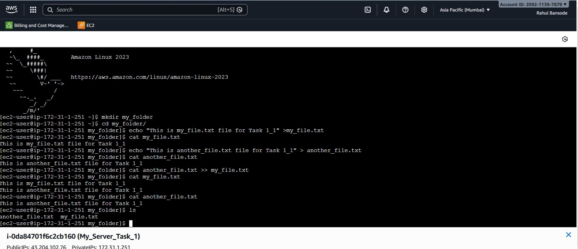

- Create 20 files with .txt extensions and rename the first 5 files to .yml extension and print the latest created top 5 files among the total no of files".
- cd my_folder/
- touch file{1..20}.txt
- ls -l
- mv file1.txt file1.yml
- mv file10.txt file10.yml
- mv file11.txt file11.yml
- mv file12.txt file12.yml
- mv file13.txt file13.yml
- ls -lt | head -n 6

Screenshot:

